**PART 1: Creating Schema.**

**Create Table Award**

**(**

**Award Varchar (50) Not Null,**

**Year Int,**

**Category Varchar (50) Not Null,**

**Movie_id Varchar (3) Not Null,**

**Star_id Varchar (3),**

**Foreign Key (Movie_id) references Movie,**

**Foreign Key (Star_id) references Star**

**)**



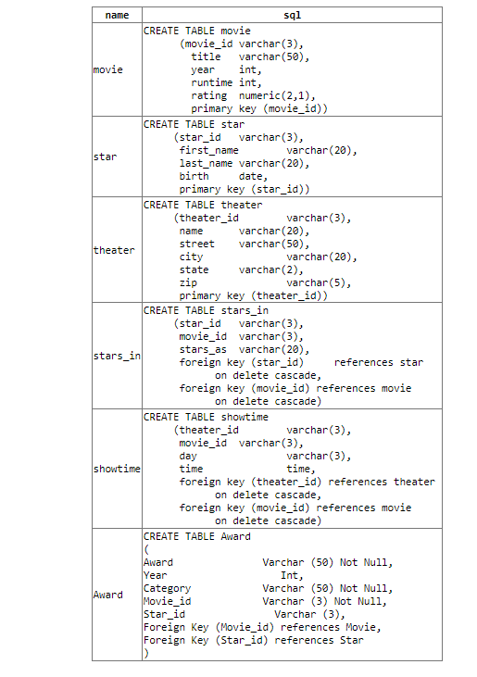



**insert into Award**

**values**

**('Oscars', 1961, 'Best Picture', 108, NULL),**

**('Oscars', 2017, 'Best Director', 109, 211),**

**('Cannes Film Festival', 2018, 'Best Director', 110, 212),**

**('Cannes Film Festival', 2017, 'Best Actress', 111,213),**

**('Oscars', 2020, 'Best Actor', 112, 214),**

**('Oscars', 2017, 'Best Actress', 109,215),**

**('Cannes Film Festival', 2019, 'Best Actor', 113, 216),**

**('Cannes Film Festival', 2009, 'Golden Palm', 114, NULL)**

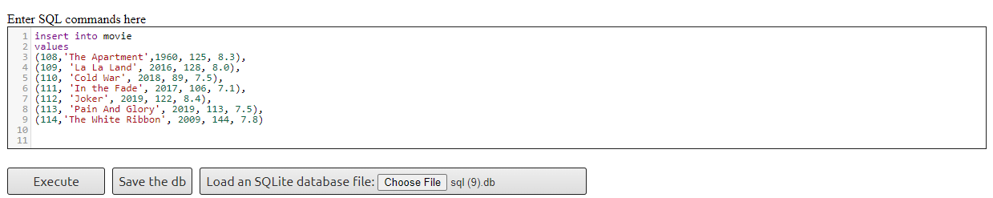

**insert into movie**

**values**

**(108,'The Apartment',1960, 125, 8.3),**

**(109, 'La La Land', 2016, 128, 8.0),**

**(110, 'Cold War', 2018, 89, 7.5),**

**(111, 'In the Fade', 2017, 106, 7.1),**

**(112, 'Joker', 2019, 122, 8.4),**

**(113, 'Pain And Glory', 2019, 113, 7.5),**

**(114,'The White Ribbon', 2009, 144, 7.8)**

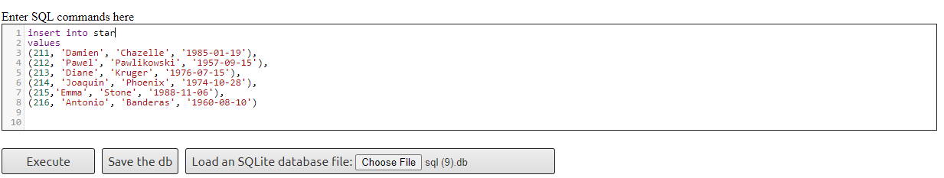

**insert into star**

**values**

**(211, 'Damien', 'Chazelle', '1985-01-19'),**

**(212, 'Pawel', 'Pawlikowski', '1957-09-15'),**

**(213, 'Diane', 'Kruger', '1976-07-15'),**

**(214, 'Joaquin', 'Phoenix', '1974-10-28'),**

**(215,'Emma', 'Stone', '1988-11-06'),**

**(216, 'Antonio', 'Banderas', '1960-08-10')**

**Content Of The Award Table.**

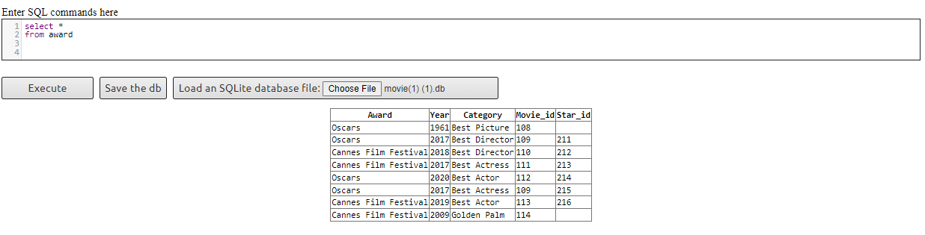

**Query 1. Find all movies that won awards. Output the movie title, the award name, the year of the award, and the award category. Order the result by the number of awards in descending order**

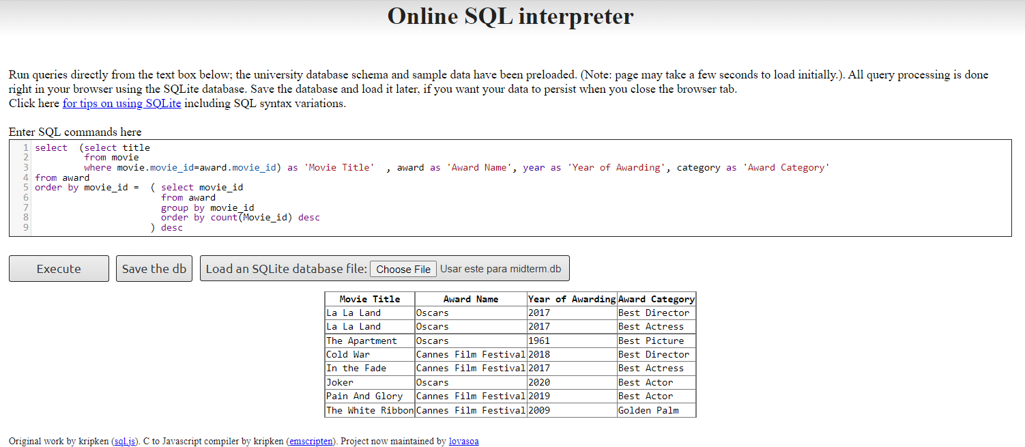

**Query 2. List all movies from the database. For each movie, output the movie title, the year of production, and the number of awards. Order the result by the year of production in ascending order**

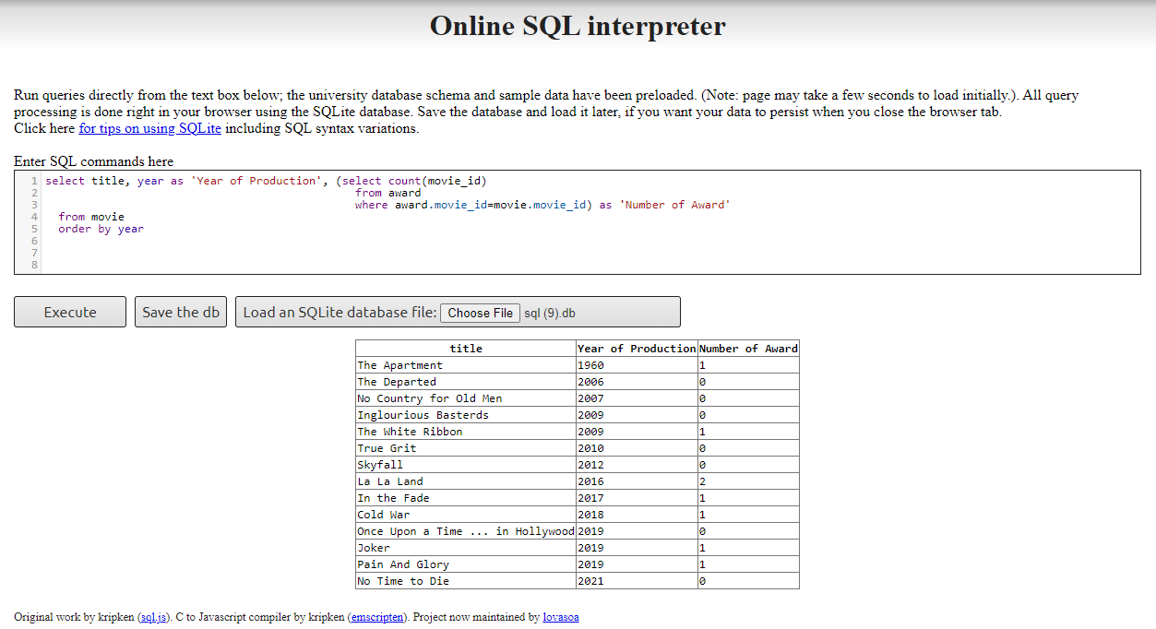

**Query 3.** **Find all stars who won awards. Output the star’s first and last name, the award name, the year of awarding, the award category, and the movie title. Order the result by the star’s last name in alphabetical (ascending) order**

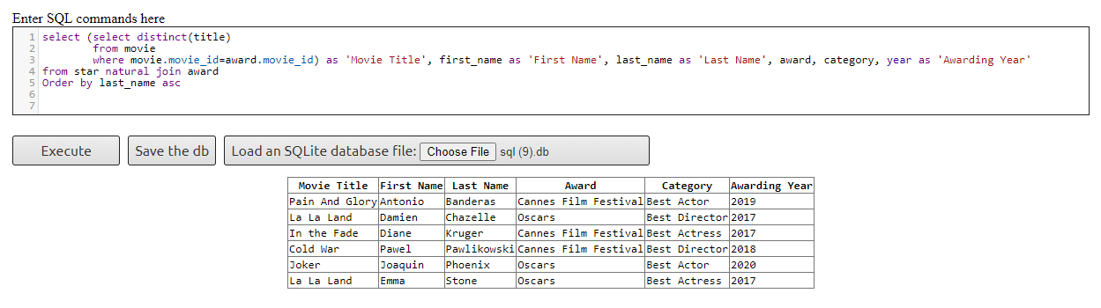

**Subquery 4. List all stars from the database. For each star, output the first name, the last name, and the number of awards. Order the result by the number of awards in descending order.**

